**MEMORIES FROM BOOT CAMPs 1 and 2**

NAME ______________________________________________________

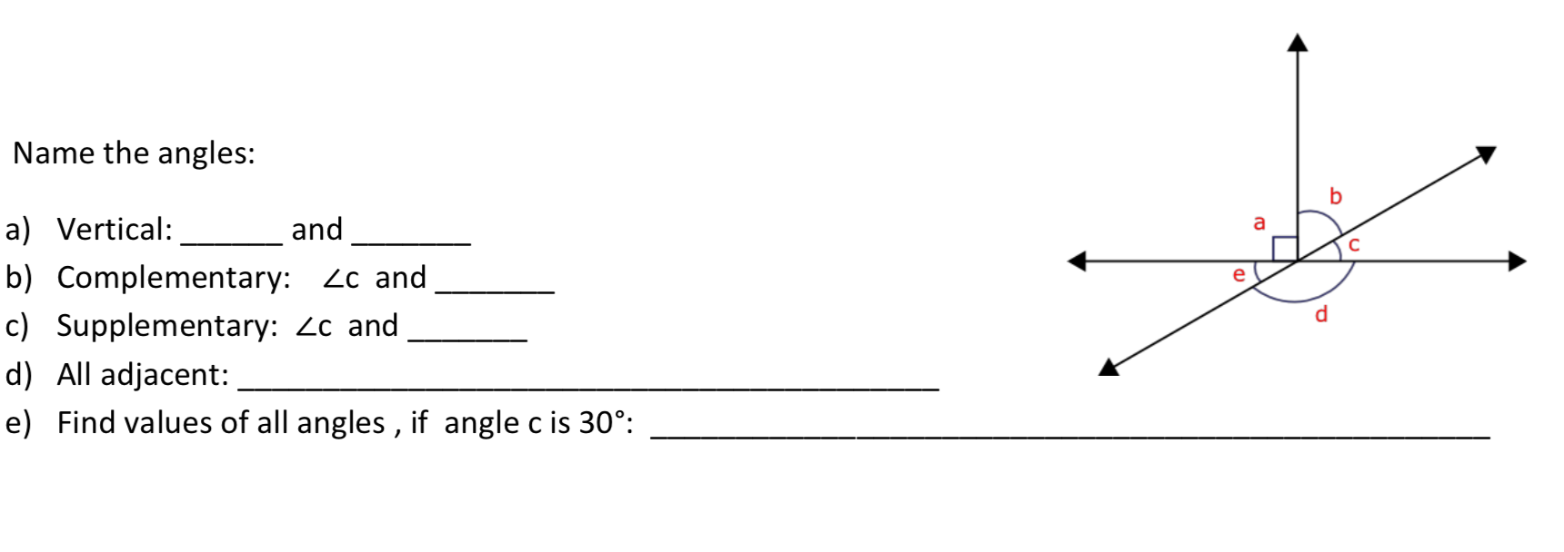

2. 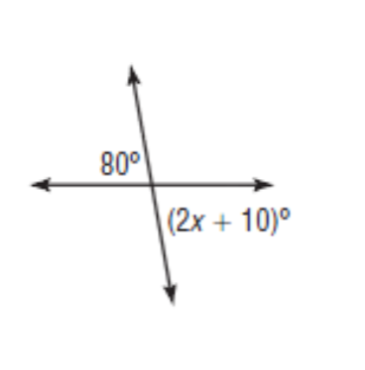Find the value of x:

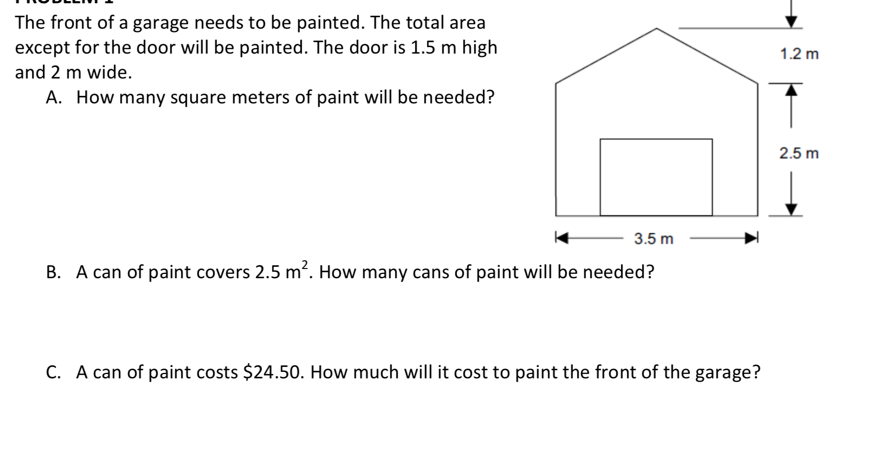



1. 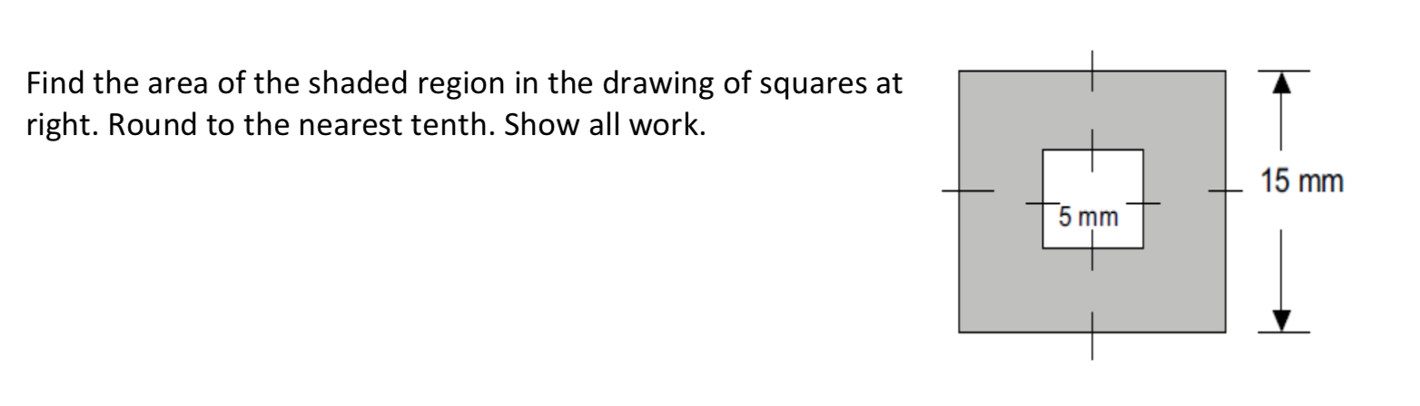
2. 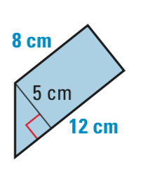 Find the area of the figure below.