

NAME ______________________________________________ Date due: ________________________

**REWIND AND REMEMBER #3**

**Tier B**

**You must turn this page in for a grade! (20 points)**

1. What is the measure of angle a? Show your work.

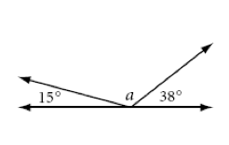

Use the drawing below to answer the questions:

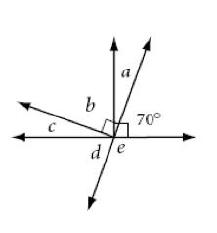

**f**

2) Name a pair of vertical angles: ___________ and ____________

1. Name a pair of complementary angles: ___________ and __________
2. Name a pair of supplementary angles: ______________ and ______________

5) Name a pair of adjacent angles: ______________ and _________________

6)

Kimberly wants to buy a sweater that is on sale. The sweater is marked for $35 and is on sale for 28% off. What is the new price of the sweater?

7) Solve for **b** when b = -2

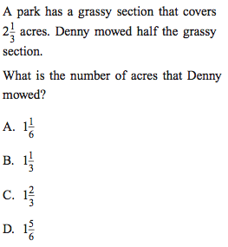8)

9) Solve: -12 + (-5) + 18- (-36)

10) Does this table represent a proportional relationship? Why or why not?

