NAME ______________________________________________ Date due: ________________________
REWIND AND REMEMBER #3 Acc
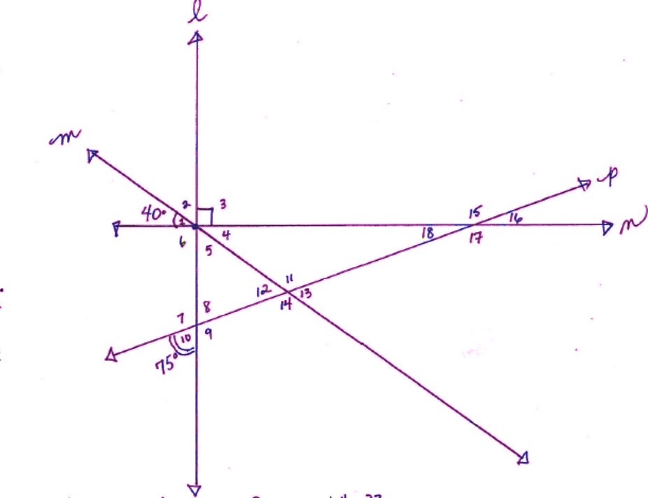
You must turn this page in for a grade! (20 points)

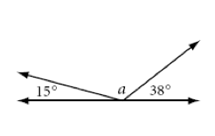

1) What is the measure of the following angles:
Angle 8 = ________ because:
Angle 12 = __________ because:
Angle 18 = __________ because:

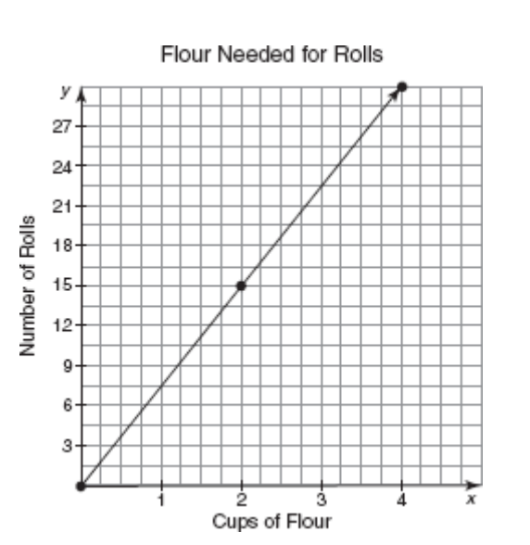
- The graph below shows the number of cups of flour needed for making rolls.

- Determine the rate of change. Explain how you determined the rate of change.

- Determine the number of cups of flour needed to make 75 rolls for a dinner party. Show your work.

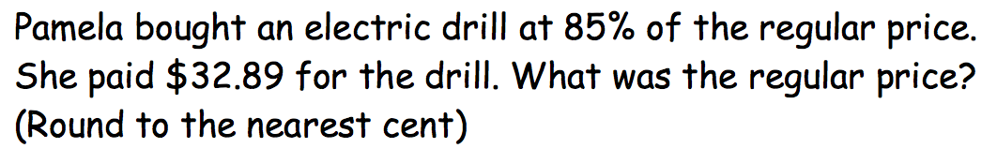
3)

4) Solve for - b- b when b = -2

5) A magic square has rows and columns that add to be a constant number. In the case below, each row and column should add to be 1. Fill in the remaining fractions and be sure to show your work. You must show your work using fractions!!!

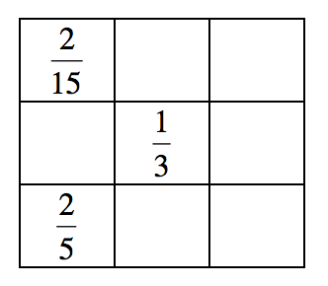

6) Solve: -12 + (-5) + 18 - (-36) - 44

7) Does this table represent a proportional relationship? Why or why not?

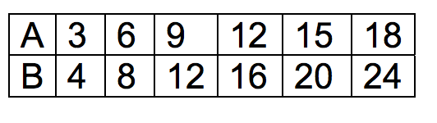

8) Write five different integers that have a mean of -10. Show your work and explain how you found your answer.

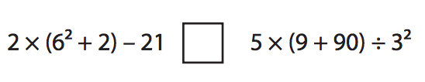
9) Place $=or ≠$ in the box below.

10) What is the measure of angle a? Show your work.

