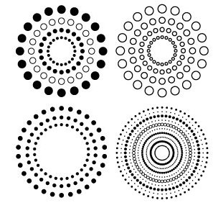
Name __________________________________

Date _______________________

Area and Circumference of a Circle Match-Up

Write the letter of the answer that matches each word problem on the line (round all answers to the 100ths place). Use 3.14 for pi. Units of measurements are removed. Show your work, including any formulas you use, on a separate sheet of paper. You may use a calculator.

______ 1) Sally buys a round dinner table. The radius of the dinner table is 6 meters. What is the area of the table?

______ 2) Chuckie has a circular carpet in his family room. He wants to put a table in the middle of the carpet. The diameter of the carpet is 12 meters and the diameter of the table is 4 meters. Calculate how much area of carpet is left after putting the table in place.

______ 3) Tommy purchases a bowl. The diameter of the bowl is 14 cm. What is the circumference of the bowl?

______ 4) Billy wants to buy cookies for his friend. The radius of the cookies is 5 inches. What is the cookie’s circumference?

______ 5) Debby makes a round pizza. She wants to put a layer of cheese on the pizza. If the pizza is 8 cm in diameter, how many square cm. of the cheese layer does she need to put on the pizza?

______ 6) Betty wants to buy a round photo frame for her brother. The radius of the photo frame is 9 cm. What is the photo frame circumference?

______ 7) Mikey made a tasty burger. The diameter of the burger was 5 cm. What was the area of the burger?

a) 56.52 b) 113.04 c) 43.96

d) 50.24 e) 19.625 f) 100.48 g) 31.40

