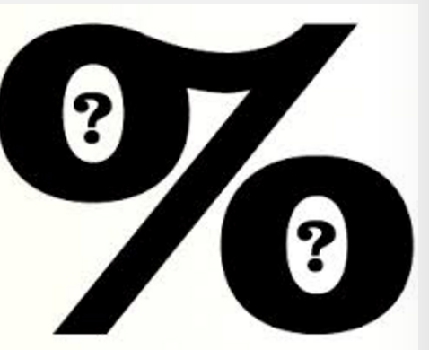
INTRO TO PERCENTS

Watch the 5:29 minute video below and answer the questions while you are watching. This will give you a basic introduction into the world of percents which is our world for the next month or so……

https://youtu.be/Hxh0tsCva8E

- Explain why 50% with an additional 10% off is not the same as 60% off.

- What does “Percent” mean?

- Explain how to change a percent into a fraction.

- Is % a value? Why or why not?

- What is APR?

- What were the 3 tips in the video?

