Four gallons of gasoline cost $16.80. What is the price per gallon? | Franklin walked ½ mile in 8 ½ minutes. What is the unit rate in miles per minute? | An artist made purple paint by mixing ½ quart of red paint and ¾ quart of blue paint. What is the ratio of red paint to blue paint in simplest form?
Emma drank 1/4 of a milk shake in 1/12 of a minute. How many minutes will it take her to  drink a full milk shake? | Lillian eats 1/4 of a pound of grapes in 1/17 of a minute. How many minutes will it take her to eat a full pound of grapes? | Sophia used 1/3 of an ounce of cheese to make 1/12 of a pound of pizza dough. How many ounces of cheese are needed to make a  pound of pizza dough?
Ellie used 1/6 of a liter of water to make 1/21 of a casserole. How many liters of water does she need to make an entire casserole? | Ashley needs to ride her bike to her friend’s house 96 miles away. She is riding at an average rate of 15 miles per hour. She has 6 hours to get there. Will she make it? | A trail mix recipe calls for 1/3 pound of mixed nuts, 4/15 pound of raisins, and 2/5 pounds of granola. What is the ratio of raisins to mixed nuts in simplest form?
A 12.5 oz bag of Doritos for $3.79 or a 3 oz bag for $1.00. | 48oz big gulp for $1.39 or a 32 oz coke for $.89. | Caleb drives for 3 hours at 15 miles per hour. How far does he travel?
50 head of cattle for $24,500 or 37 head of cattle for $18,870 | 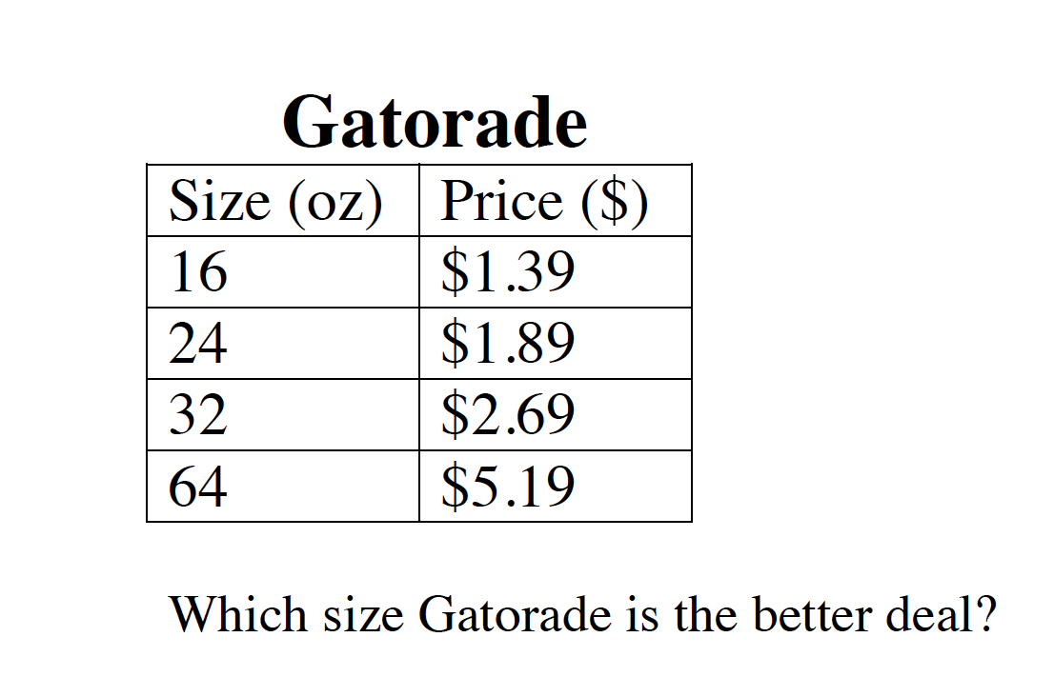 | Claire power walks 1/9 of a mile in 1/54 of an hour. Compute the unit rate as the complex fraction.
Making Unit Rates with Fractions

