Name _______________________________

Solving Equations with the Variable on Both Sides

1) 6r + 7 = 13 + 7r

2) 13 - 4x = 1 - x

3) -7x - 3x + 2 = -8x - 8

4) -8 - x = x - 4x

5) -14 + 6b + 7 - 2b = 1 + 5b

6) n + 2 = -14 - n

7) n - 3n = 14 - 4n

8) 7a - 3 = 3 + 6a

9) -10 + x + 4 - 5 = 7x - 5

10) -8n + 4(1 + 5n) = -6n - 14

11) -6n - 20 = -2n + 4(1 - 3n)

12) 4n - 40 = 7(-2n + 2)

13) 7(5a - 4) - 1 = 14 - 8a

14) -31 – 4x = -5 - 5(1 + 5x)

15) 38 + 7k = 8 (k + 4)

16) 3(1 – 3x) = 2(-4x + 7)

17) -3(x – 1) + 8(x – 3) = 6x + 7 – 5x

18) $3x-15+2x= \frac{-x-5}{4}$

19) $\frac{3x-27}{5}=7x-3$

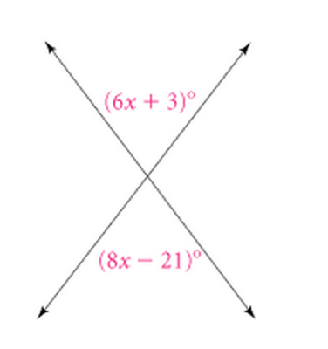
20) Solve for x and then tell the measure of each angle.

21) The perimeters of this rectangle and equilateral triangle are equal. Write an equation using the distributive property and then tell What their perimeter is.
