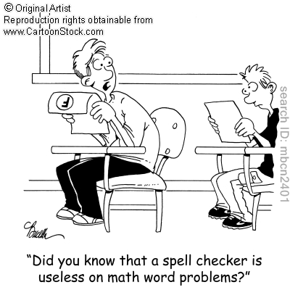
Name ___________________________________
Date __________________________
Period _______________

Unit 6 Word Problems
- Tyler and Melissa each have gumdrops. The amount that Tyler has is equal to five more than the amount that Melissa has. What is the number of gumdrops that Tyler has if there are 31 gumdrops between them?

- Three times the sum of a number and 1 is equal to 21. What is the number?

- Hannah is half as old as her aunt. The sum of their ages is 42. How old is Hannah?

- Henry ate two less than triple the number of candies that Noah ate. If they ate a total of 30 candies, how many did each person eat?

- A person spots 25 birds and squirrels in the park. If there are 3 more squirrels than birds, how many of each animal is in the park?

- At a middle school there are a total of 210 students who participate in the newspaper club and the yearbook club. 6 less than 3 times as many participate in the yearbook than the newspaper. How many students participate in each club?

