

NAME ______________________________________________ Date due: ________________________

**\*\*REWIND AND REMEMBER #6\*\***

**You must turn this page in for a grade! (20 points)**

1. The probability that a new car at a local dealership has a bad headlight is 0.003. Which statement best describes the probability of this event?

1. It is likely that a new car at a local dealership has a bad headlight.
2. It is unlikely that a new car at a local dealership has a bad headlight.
3. It is neither likely nor unlikely that a new car at a local dealership has a bad headlight.
4. It is impossible that a new car at a local dealership has a bad headlight.
5. Find the surface area of the 3-by-3-by-3 cm. cube below.

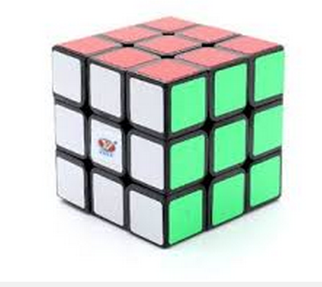

Remember: Find the area of each side and then add all 6 sides together.

1. A circular mirror has a radius of 6 inches. What is the circumference of the mirror?
2. Simplify: $-3b (2c+4)$
3. Solve for **a - b** when a = -1, b = -2, and c = -3
4. Find the surface area and volume of the following sphere: (you may use your reference sheet, and a calculator)

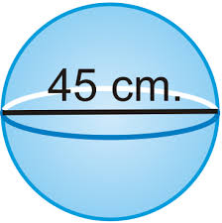

8 cm.

$$FORMULAS:$$

$$SA = 4πr^{2}$$

$$V= \frac{4}{3}πr^{3}$$

1. Solve: $50-(2^{3}-2)÷6$
2. Using the diagram with the given angle measures, find the value of x:

8x

3x + 4

Remember 2 angles on a line will equal 180 degrees!

1. Greg has just started a new job at a grocery store down the road. He lives within walking distance of it. It takes him 30 minutes to walk there. He lives 4/5 of a mile from the store. What is his speed when he is walking to his job? (show your work!)

Formula to use: ________________________________

10) Solve: