Name _____________________________
Unit 7: Take Home and Check

Date _____________________
Updated 2016
Period __________

Identify the population and sample in each situation:
- Researchers poll every fifteenth voter after a school board election.

- A swim instructor asks 5 of his students which stroke they prefer.

The manager of a supermarket is conducting a customer survey. State whether each sampling method is random or not random. Explain your answer.

- The manager surveys customers in the store every Monday morning.

- The manager questions every 6th customer from a list of all customers.

- The manager questions only customers who shop with children.

- A student thinks that school bus stops in his community are too far apart. He surveys all the students in his class to see what they think. What is the population? What is the sample? Is the sampling method random?

- Some commuters into Boston were asked how many minutes they lived from work. Their responses were 15, 7, 14, 21, 5, 9 and 12. Find the mean, median, mode and range of their times.

Would you use mean, median, mode or range for each situation? Explain your answer.

- Kevin noticed that half of the cereal brands in the store cost more than $3.33.

- The average score on the last pre-algebra test was 85.

- The most common height on the basketball team is 6ft.. 11 in.

- The heights of the players on the basketball team vary by 6 inches.

12) Carla has three tests scores of 84, 90 and 86. There is one more test during the semester. She wants to have at least a 90% average in the class. What grade does she need to get on the last test?

Find the mean, median, mode and range of the following data.
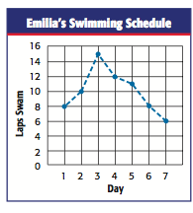

13) Mean:

14) Median:

15)Mode:

16) Range:

Write a B or U on the line before each statement labeling it as biased or unbiased.

17) __________ A phone-in survey is taken by a radio station to see how many listeners enjoy jazz in the morning.

18) ____________A city councilman asks members of the ice hockey team if they would prefer a new skateboard park or a new ice rink to be built as the town building project.

19)____________Are you willing to deal with noisy, heavy increases in traffic where you live just so another unnecessary mall can be built (is this statement bias or unbiased).

Answer the following questions:

20) Veterinary doctors marked 30 deer and released them. Later on, they counted 150 deer, 12 of which had marks. To the nearest whole number, what is the best estimate for the deer population?

21) Andrew is a buyer for Marshall’s and is deciding what to buy for the store chain. He collected two random samples of 100 men regarding their men’s wear preference. Make at least two inferences based on the results.

Student sample | Jeans | Pants | Shorts | Total
#1 | 78 | 10 | 12 | 100
#2 | 64 | 22 | 14 | 100

22) Calculate the Mean Absolute Deviation of the weekly allowance of middle school students. Be sure to show your steps! (Round the mean to nearest whole number)

Weekly Allowance of Middle School Students
$15 | $25 | $25 | $35 | $20 | $20
$15 | $10 | $20 | $15 | $25 | $10

23) A student plans to survey randomly selected spectators at a school football game. For which question will the sample be the MOST representative of the relevant population? Why?

- Which food should be added to the concession stands at the football stadium?
- Which activities should be offered for the school’s activity day this year?
- How should we spend the money from the annual fundraiser?
- Which play should the drama club perform next?

24) Researchers count 48 marked deer and a total of 638 deer on a flight over an area. They know there are 105 marked deer. Write a proportion to estimate the deer population in the area. Tell what the estimate is.

25) Which is the best way to survey a random sample of students from your school about their favorite radio station? Explain.

- Survey 5 students in each first-period class
- Survey 12 students in the band
- Call 25 friends
- Survey each student in your math class

26) A government inspector takes 5 random samples of the same size from a shipment of eggs. She determines the mean weight of a dozen eggs in each sample. What can the inspector conclude if the mean weights of the samples are very close to each other?

27) The box and whisker plot shows the prices of shirts at Store A and Store B. Compare each pair of measures for the data sets in the box and whisker plot, and use each comparison to draw an inference.
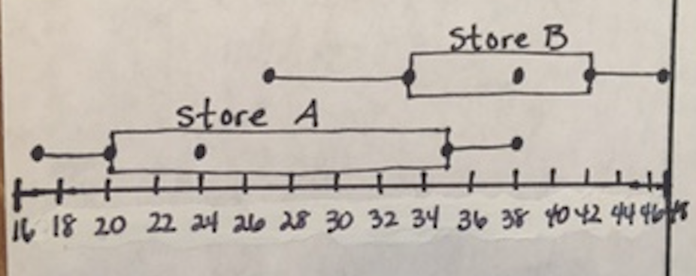

28) Two data sets have means that are very far apart and the MADs of the data sets are very small. What can you conclude about the amount of overlap in the data sets? Explain.

