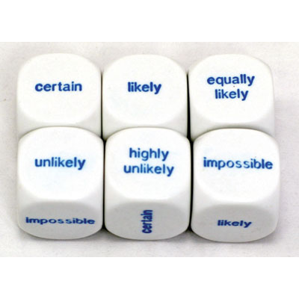
Name ___________________________________

Date ______________________

Probability
Experimental/Theoretical and Likelihood
I. Color in the box on the probability scale below beside the percentage that you think represents your choice for each event.
 | #1 | #2 | #3 | #4 | #5 | #6 | #7
100%
90%
80%
70%
60%
50%
40%
30%
20%
10%
0%

- You will wake up tomorrow.
- You will love your dinner tonight.
- You will eat breakfast tomorrow.
- You will have a quiz or test either this week or next week.
- You will win a trip to New Zealand this year.
- An event A is an impossible event. What is its probability?
- A teacher choosing a boy from a class of 9 girls and 9 boys.

II. Make a probability line below and place the 7 events above on your line.

III. Explain the difference between experimental and theoretical probability. Include:
- Definitions of each term
- An example of each term
- Explain the biggest difference between the two.

