Watch the video on my website: Unit 7, More Videos, #1 How to Make a Box and Whisker Plot
How to Make a Box and Whisker Plot

Answer the questions below:

- List the steps you take to make a box and whisker plot:

1)

2)

3)

4)

5)

- Tell what each of the parts of a box and whisker plot are:

- median –

- quartile –

- minimum –

- maximum –

- whisker –

- box –

- Label the parts of the box and whisker plot below. Use the 6 vocabulary words from above.

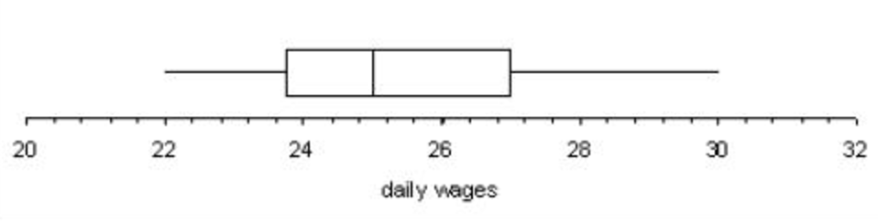

- Make a box and whisker plot from the data below.

