Your Name: ____________________________

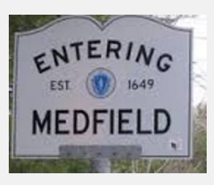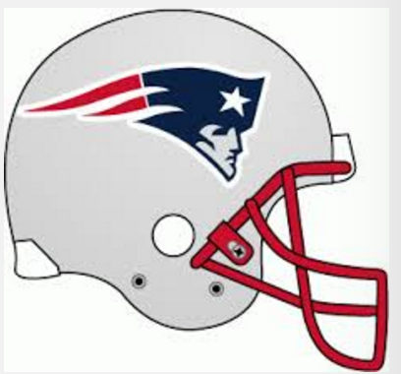

What I learned in this unit:



What I expect to learn in this unit:



Date unit started:

Date unit test:

UNIT 1

Signed Numbers