

NAME ______________________________________________ Date due: ________________________
REWIND AND REMEMBER #5 (Reg)
You must turn this page in for a grade! (20 points)

- Simplify and then combine like terms: 2x - 3x + 2(x + 7) =

2) Apply the distributive property and then simplify: 5(f + 12 – 2e) – 2f =

- 5${}^{2}$ + 2${}^{3}$ - 7${}^{0}$ =

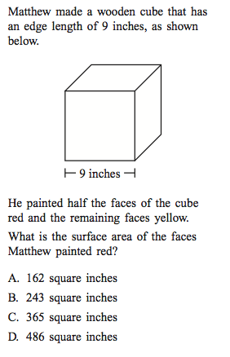
4)

5) Solve for - b${}^{2}$ when b = -2

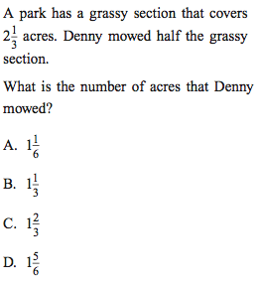
6)

7) Apply the distributive property and then simplify: – 2b(b+ 6 – 5b + 9)

8)Identify the property shown: (5 + 6) + 12 = 5 + (6 + 12)

9)Give a simplified expression for the perimeter and area of this figure:
X + 3 inches

X inches

Perimeter:

Area:

10) Solve:
