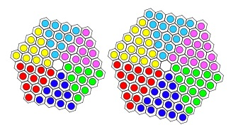
NAME _________________________
DATE _________________
PERIOD _______

Patterns & Sequences

Write the next 5 terms of each of the following sequences then make them into a table:

1) 1, 4, 7, 10, _____, _____, _____, _____, _____
Term | 1 | 2 | 3 | 4 | 5 | 6 | 7 | 8 | 9
Value | 1 | 4 | 7 | 10

What is the pattern? ______________________

2) 1, 3, 6, 10, _____, _____, _____, _____
Term | 1 | 2 | 3 | 4 | 5 | 6 | 7 | 8 | 9
Value

What is the pattern? ______________________

3) 2, 5, 9, 14, _____, _____, _____, _____, _____

Term | 1 | 2 | 3 | 4 | 5 | 6 | 7 | 8 | 9
Value

What is the pattern? _____________________

In sequences 4 through7, fill in the terms and the values:

4) 2, 5, 10, 17, _____, _____, _____, _____, _____
Term
Value

What is the pattern? ______________________

5) 10,000, 1,000, 100, 10, _____, _____, _____, _____, _____
Term
Value

What is the pattern? ______________________

6) 1, 4, 9, 16, _____, _____, _____, _____, _____
Term
Value

What is the pattern? ______________________

7) 1, 8, 27, 64, _____, _____, _____, _____, _____
Term
Value

What is the pattern? ______________________

Write the next five terms of the famous
Fibonacci Sequence:
TERM  X | VALUE  Y
1 | 1
2 | 1
3 | 2
4 | 3
5 | 5
6
7
8
9
10
1, 1, 2, 3, 5, . . . . . . .

Describe the Fibonacci Pattern:

______________________________________

THE SQUARE SEQUENCE
Extend this dot pattern:
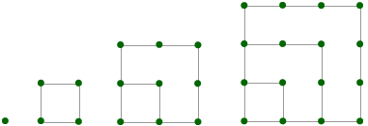 _______________________
The number of dots in each square forms a sequence of numbers. Write the first 10 terms in this sequence:
Term
Value

Describe the pattern ___________________________

THE TRIANGLE SEQUENCE
Extend this dot pattern:
_________________
The number of dots in each triangle forms a sequence of numbers. Write the
first 10 terms in this sequence:
Term
Value

Describe the pattern ___________________________
Add pairs of numbers that are next to each other in the sequence. What do you
notice? ___________________________________________________________

