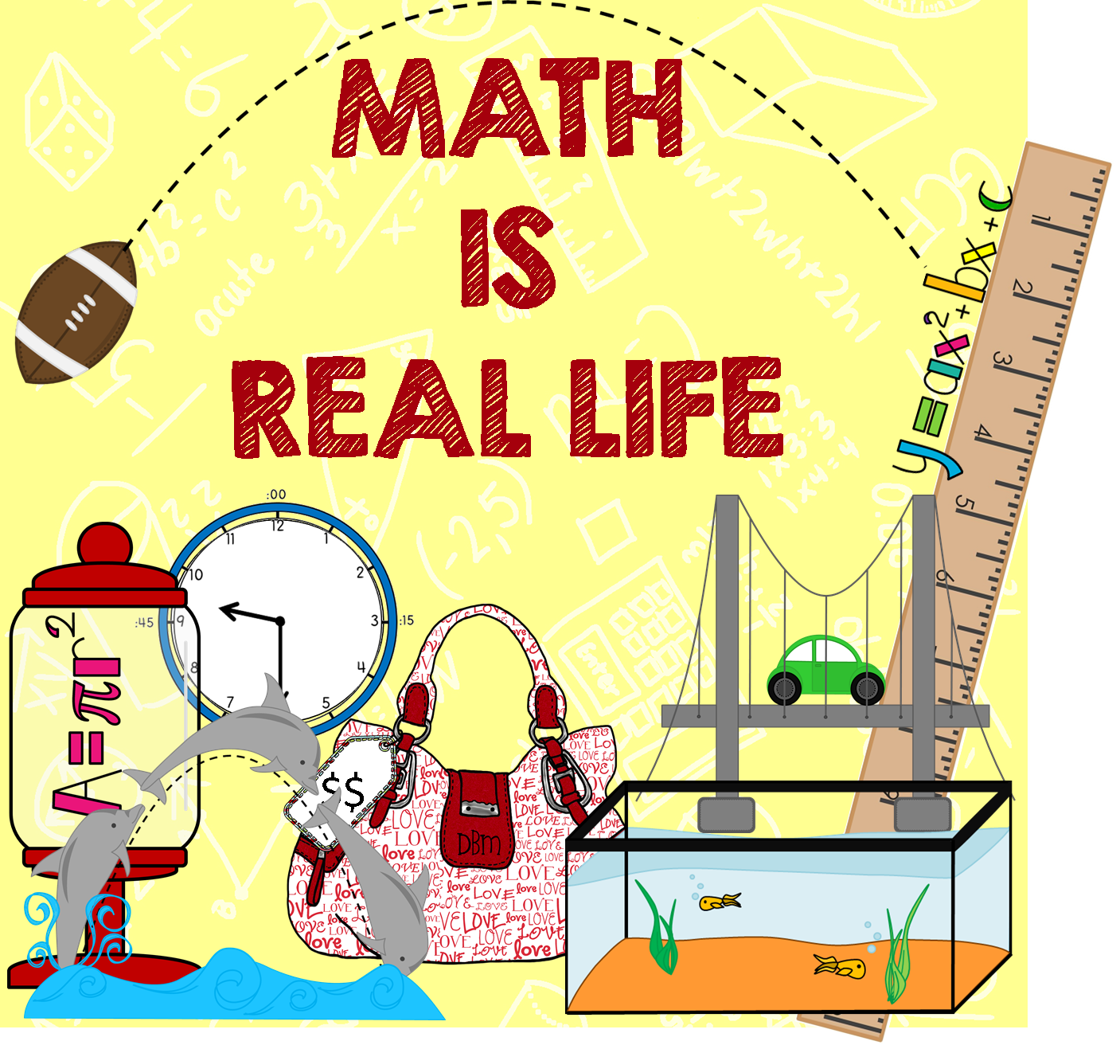
Name _________________________________

Date _______________________
Practice with Combining Like Terms and the Distributive Property

- $-9-9(p-3)$

- $3\left(6-4n\right)+10n$

- $-4\left(1+5r\right)+9=$

- $-5b-7\left(b-6\right)+2=$

- $a+9\left(a-3\right)+2a=$

- $2b-4+3b \left(b-6\right)- 4b^{2}=$

- $-15+2 \left(p-9\right)+ 21=$

- $5t-\left(t+7\right)- 18=$

- $8a^{3}-2a^{2}+a\left(a-7\right)+ 3a^{3}=$

$$10) -9+5 \left(2b-3\right)- 24b+12=$$

