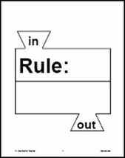
Name _______________________________________

Date ______________________

Graphing Linear Equations

Use the equations to create a function table. Graph the ordered pairs on the coordinate plane and then tell what type of slope each line has.

1) $y=2x+4$
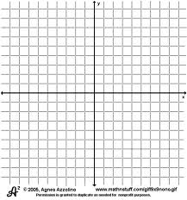

x | Equation | y | (x,y)

Slope: ___________________________________

2) $y=5x-3$

x | Equation | y | (x,y)

Slope: _________________________________

3) $y= -3x+1$

x | Equation | y | (x,y)

Slope: _______________________________
4) $y= -2x+6$

x | Equation | y | (x,y)

Slope: _____________________________

5) $y= -x+5$
x | Equation | y | (x,y)

Slope: ____________________________
6) $y=6x-5$

x | Equation | y | (x,y)

Slope: ___________________________________

7) $y= \frac{3}{4}x-3$
x | Equation | y | (x,y)

Slope: ____________________________________

