Emma and Her Horse
Name _____________________________________________________

The graph below shows the varying speeds at which Emma exercises her horse. Let’s look at the graph and try to interpret what is happening.

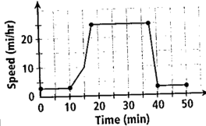
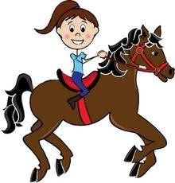

- Read the axes names. Look at the intervals. What do you see?

- Divide the graph into sections.

- Write something about each section.

