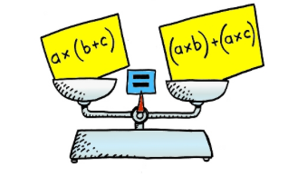
Name ___________________________________

Distributive Property Word Problems to Practice

Write expressions for the problems below using the distributive property. Solve if you are asked to solve.

- The price for each notebook is p. The number of notebooks bought by Lily, Jim and Jessica is a, b, and c. Write an expression to represent the total cost of all the notebooks bought by the 3 people.

- The price of each meter of wire is u, and there are 3 parts of wires whose lengths are x, y and z. Write an expression, which represents the cost of buying the 3 parts of wire.

- For two days, your boss decides to double the commission on what you sell. If on day 1, you make f dollars in commission and on day 2, you make g dollars in commission, write an expression for the total commission you earn.

- You have six gummy worms and eleven sticks of gum. Your friend is going to double the amount of the candies because you helped her babysit her brother last Friday. Write an expression for this scenario. Simplify the expression to determine how many gummy worms and sticks of gum you will now have.

- Roberto was planning his birthday party. He estimated that each person at his party would eat 2 ½ hamburgers and 1/5 of a bag of chips. If he invites 12 friends to his party, how much of each will he need? Write an expression and solve it.

- Larry was collecting rocks for her science project. She found 3 examples of limestone, 4 of shale, and 1 example of sandstone on her nature hike. Lily found 3 times what Larry found. Write an expression showing how many of each rock Lily found.

7) Describe the area of the figure below with an expression using the distributive property.
