Name____________________________
Date________________
Period____

Distance - Rate - Time Word Problems
1) An aircraft carrier made a trip to Guam and
back. The trip took seven hours and averaged 6
km/h. Find the distance traveled.
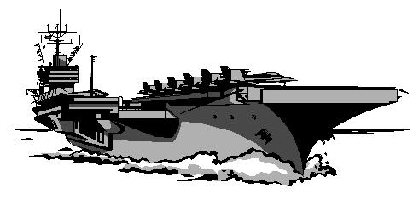

2) A passenger plane made a trip of 725 miles
to Las Vegas and back. It flew 432 mph.
How long did the trip take?

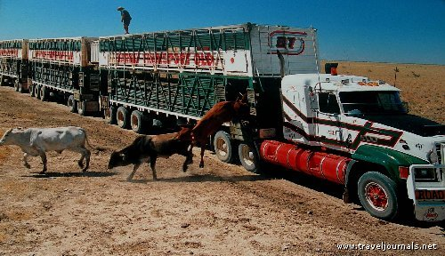

3) A cattle train left Miami and traveled toward
New York. 14 hours later, and after traveling
900 miles it finally arrived! What was the cattle
train's average speed?

4) Rob left the White House and drove toward
the recycling plant at an average speed of 40
km/h. After driving for 300 mins Rob
arrived at the plant. How far did he travel?

5) A cargo plane flew 560 miles to the maintenance
facility. The average speed on the trip was 220
mph. How many hours did the trip
there take?

6) Kali left school and traveled toward her
friend's house at an average speed of 40
km/h. Find the number of hours
Kali needs to travel to get to her friend’s
house 400 km away.

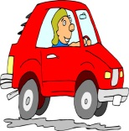

7) Ryan left the science museum and drove
at 42 km/h. After two hours he finally got there.
Find the distance Ryan traveled.

8) A submarine left Hawaii traveling
at 25 mph for 225 minutes. How
far did it go?

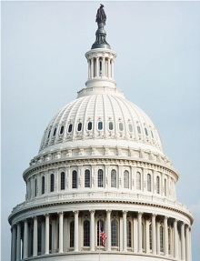

9) Chelsea left the White House and traveled
towards the Capitol at an average speed of 34
mph. It took her 30 mins to get there. What
is the distance she traveled?

10) Jose left the airport and traveled toward the
beautiful snow capped mountains at a speed of
35 mph. After 1.2 hours he finally arrived.
Find the distance Jose traveled.

