**NAME _______________________________**

Updated 2017

Updated 2013

**This part is due on: ______________________**

**ACCELERATED**

**Creature Feature: Torso**

**Assignment 1**

This week you will build the torso of your creature. Remember the torso is the part from below the neck to the top of the legs.

1. Use at least 5 **DIFFERENT solids** – drawn as polygons on your graph paper. Attach them together with glue, staples, tape or any other creative way you may invent. Remember your drawing will be 2-dimensional, but your creature is 3-dimensional. Be careful not to use only quadrilaterals. You must have THREE different polygons, not just different shapes (so they should each have a different number of sides!). ONE OF YOUR SOLIDS MUST BE A RECTANGULAR PRISM.
2. You will be covering all the sides with wrapping paper, paper bags, white paper, construction paper, contact paper, paint, spray paint, or any other covering material eventually. At this point, you want to be sure it is secure. Remember you can cut shapes out or build them yourself – it may be hard to find a box that is a hexagon but you can make one yourself. The important thing is to be creative!
3. You will be adding a small circuit to your creature so that one part or more can light up, move or make noise. Make your plan and decide where you will put the circuit. You need to leave room for it as you are building.
4. Measure each solid in length and width. All measurements should be in inches. Even though your actual shapes have 3 dimensions you only need to measure 2 of them.

length

Ex: width ____________width

length

1. Take a picture of your creature. Go to the video diary (slides) for your class and upload your picture. Upload your pictures in alphabetical order. Your slide must include your name, the highlight (best part) of this assignment and the hardship (most difficult part) of the assignment. Add arrows to point out your shapes and label them. You will also explain the process that you used to attach your shapes together. **Be careful not to make changes to all the slides – just your own.**

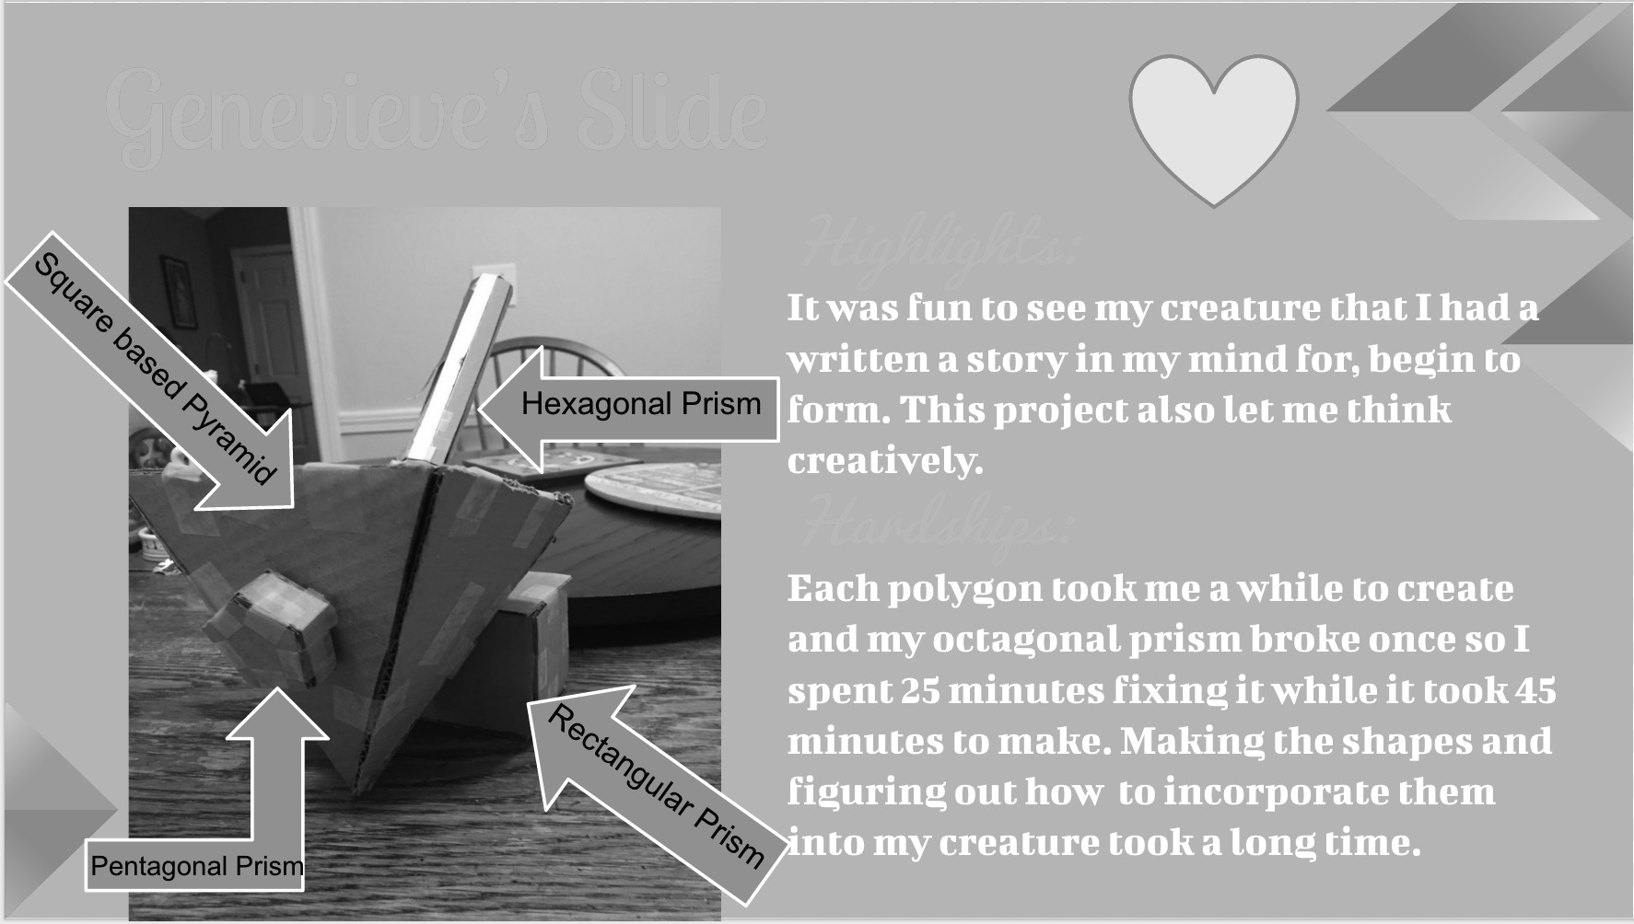

SAMPLE SLIDE

[](http://images.google.com/imgres?imgurl=http://www.cesa7.k12.wi.us/newweb/content/acadec/images/checkmark.jpg&imgrefurl=http://www.cesa7.k12.wi.us/newweb/content/acadec/Coaches_Workshop.asp&h=258&w=350&sz=19&tbnid=npIJIF1RzsgJ:&tbnh=85&tbnw=115&start=17&prev=/images?q=check+mark&hl=en&lr=&sa=G)

**RUBRIC: Assignment 1: 11 points**

**Check off each step as you complete it.**

__________ 5 different solids (one must be a rectangular prism) assembled to become your torso. Should not be larger than 2 feet tall. (4 pts)

_______________ Photo of your solids attached together uploaded to photo diary with your name and highlights and hardships. (3 pts)

___________ Neatness (2 pts)

___________ Creativity, Effort (2 pts)

NAME _______________________________________________________

CALCULATIONS:

ASSIGNMENT # 1 ACC

My 5 solids are: Shapes I will have on my drawing:

Example:

Triangular prism Triangle

____________________________ _____________________________

____________________________ _____________________________

____________________________ _____________________________

____________________________ _____________________________

____________________________ _____________________________

Are my shapes solidly connected together? _________________________

Dimensions of my solids:

________________________________________ Length= ____________ Width= ___________

________________________________________ Length= ____________ Width= ___________

_________________________________________ Length= ____________ Width= ___________

__________________________________________ Length= ___________ Width = ___________

__________________________________________ Length= ___________ Width = ___________

TURN OVER PLEASE…….

I am planning to use my circuit to _____________________________________________________________________________________________________________________________________________________________________________________.

I will place the circuit: ______________________________________________________________________________ .