Name ______________________________

DUE: _________________________________________________

Date ____________________

Period __________
Open Response #2

- Be sure to answer and label all parts of the question.
- Show all your work (diagrams, tables, or computations) on the answer sheet, which you have been provided. (you do not have to use the graph box if you do not need it)
- If you do the work in your head, explain in writing how you did the work.
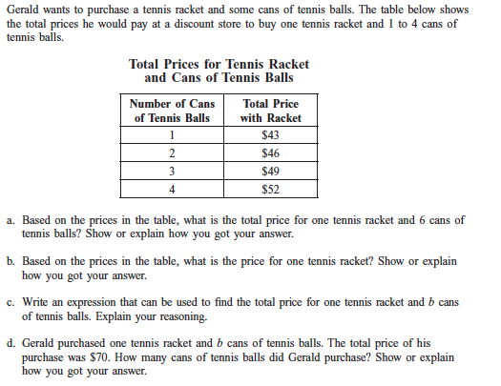

Answers correct?
- ______
- ______
- ______

Show or explain?
- ______
- ______
- ______
Comments:

Final Score: $\frac{}{4}= \frac{}{16}$

