Open Response Question #2 Date due: _____________

Name ___________________________________

Please read the given situation carefully. Then, answer each question on the paper attached.

Situation:

Mr. Seidel presents the following problem to his class:
Simplify the expression: 310 – 20 ÷ 2 × 5 + 13

Below are three student answers:
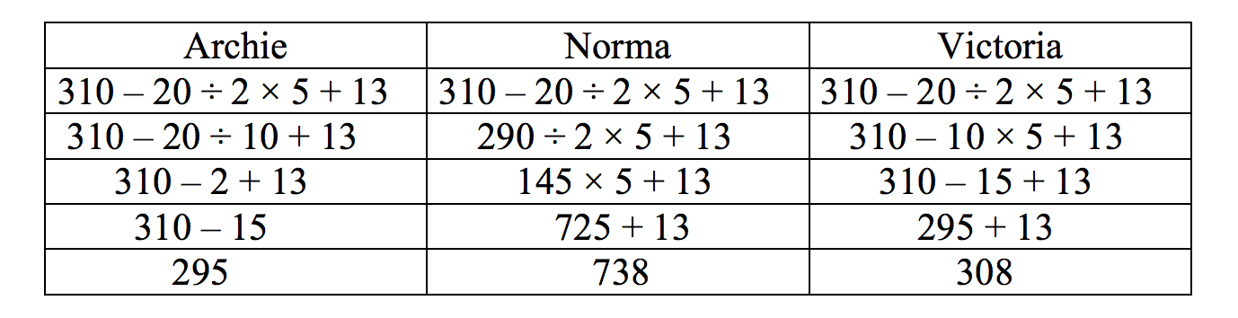

a) Archie made two mistakes. EXPLAIN what those two mistakes were in regards to the order of operations.

b) Simplify the expression yourself using the order of operations. Put a box around your final answer.

c) Based on what you see, which of the three students knows
the MOST about the order of operations? EXPLAIN why you chose that student over the other two students.

d) Where could you insert parentheses in the original problem so that the answer would be 130? PROVE IT by doing the problem with the parentheses inserted where you think they should go.

