Name _______________________________

Date due ____________________

Open Response (16 pts)

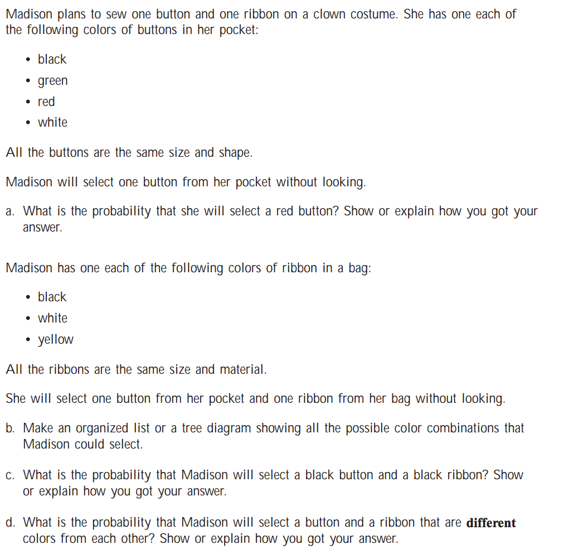
Use the paper provided to answer the questions below.

