Name ________________________
Date _______________Per ______

Using Formulas to Find Surface Area and Volume of Rectangular Prisms and Cylinders (40 pts)
(You may use a calculator and your formula sheet)
In Exercises 1-3, decide whether the net can be rolled to form a cube. (1 pt each)

- 2) 3)

Circle: Yes or No Yes or No Yes or No
In Exercises 4-9, find the surface area and volume of each figure. Be sure to show the formula you are using and put parentheses in to show your substitutions. (4 pts) You may do your work on another sheet of paper if you need to.
27 cm
18 cm
12 in
5 in
22 ft
15 ft
4 ft.
4. 5) 6)

Surface Area = Surface Area = Surface Area =
Volume = Volume = Volume=
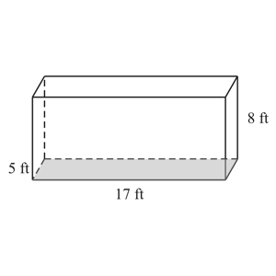
7) 8) 9)
9.9 cm
3.4 cm
12 in
12 in
12 in

Surface Area = Surface Area = Surface Area =
Volume = Volume = Volume=

10) Draw a net of a rectangular prism with the dimensions L = 5 cm., W = 4 cm., and H = 2 cm. Be sure to draw using a ruler and label the dimensions on your drawing. Also, draw it to match the dimensions. (4 pts)

11. The following table names three different solids. Complete the table. Make neat drawings! (9 pts)

Solid Figure Name | Number of Faces | Number of Edges | Number of Vertices | Draw it!
Triangular Pyramid

Triangular Prism

Rectangular Pyramid

